Prompt (1.1):
I have attached a use case diagram. I want you to understand the diagram and extract all the functional and non-functional requirements. The output should be traceable and well-formatted.

Summary:
Model | Coverage | Clarity | Traceability | Completeness | Redundancy | Overall
ChatGPT | 85 | 90 | 80 | 85 | 90 | 86
Claud AI | 95 | 85 | 95 | 95 | 80 | 90
DeepSeek | 80 | 80 | 85 | 80 | 85 | 82
Grok AI | 75 | 75 | 70 | 75 | 75 | 74
Microsoft Copilot | 90 | 95 | 90 | 90 | 85 | 90

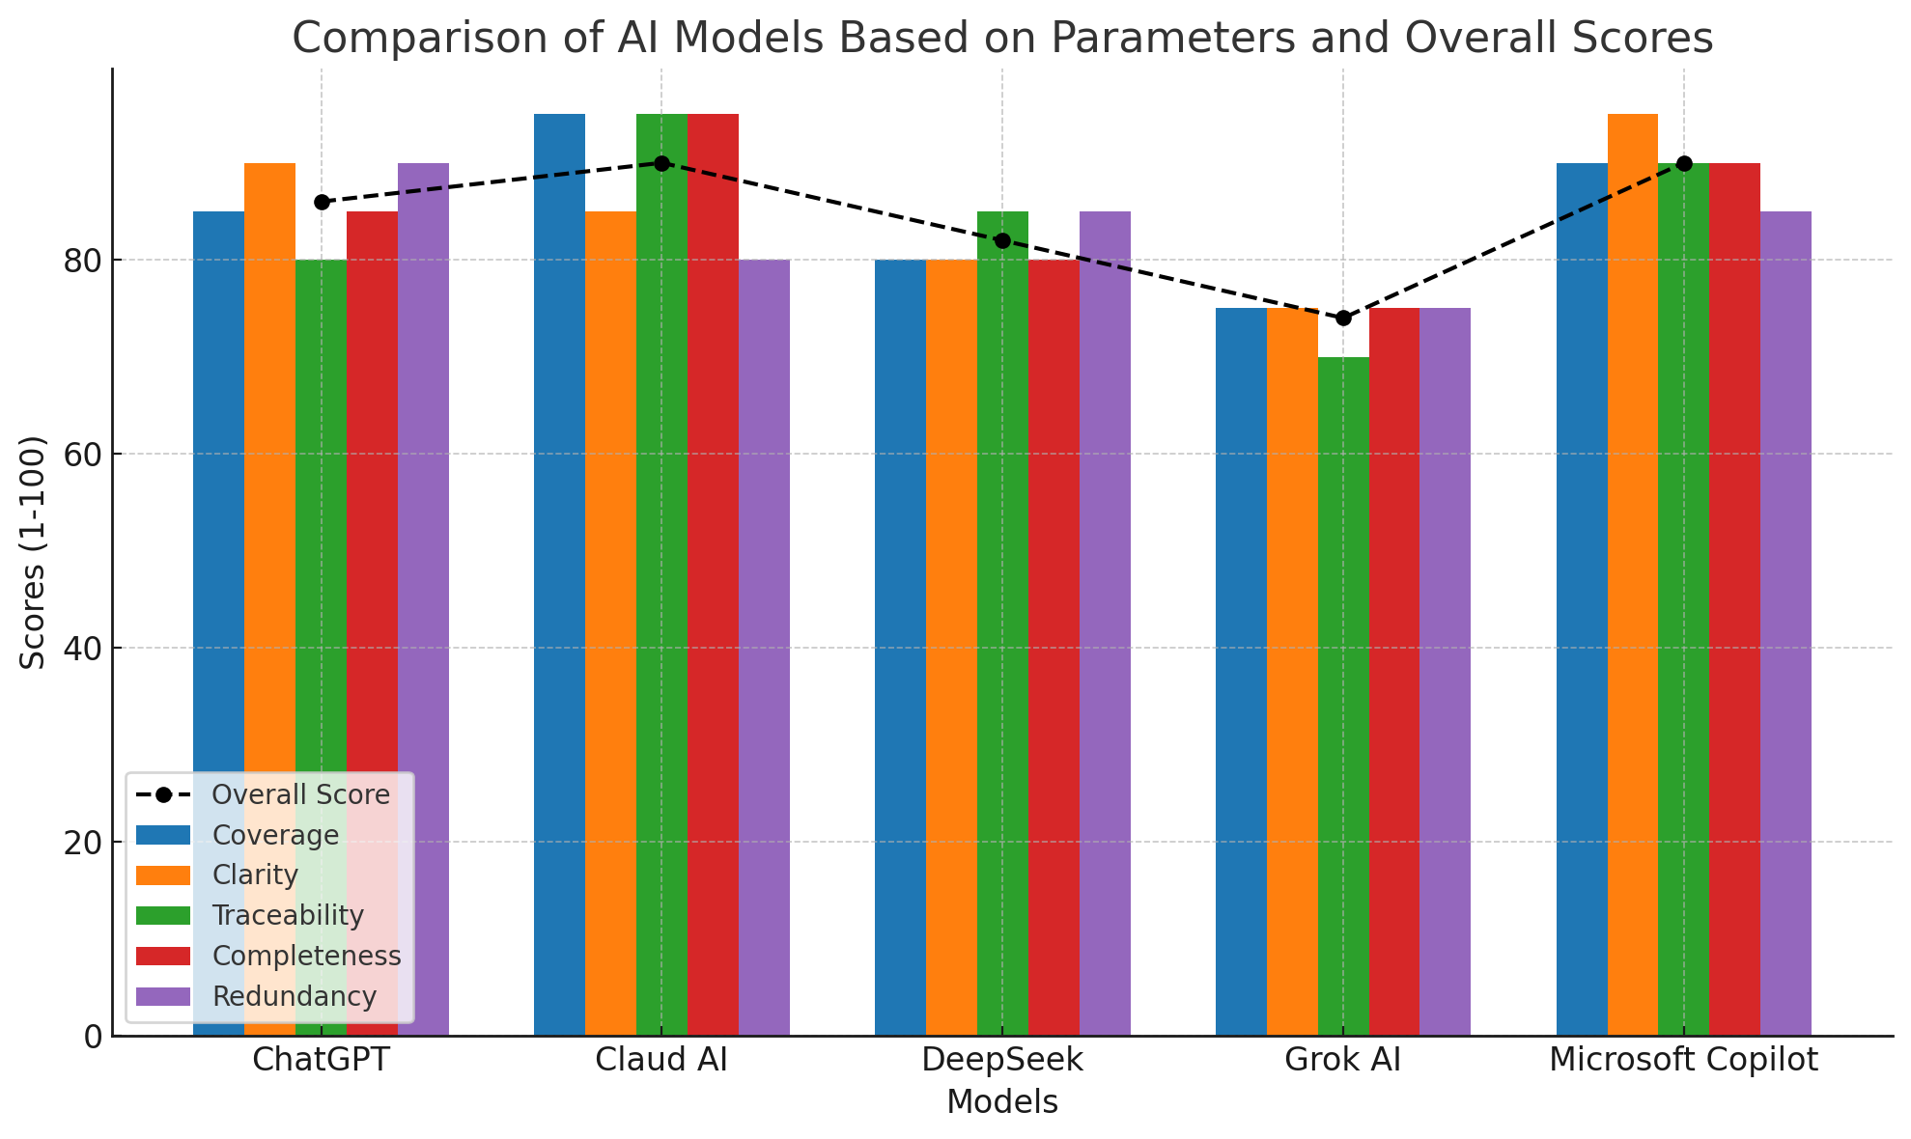

Detailed Analysis
1. Coverage
- Best: Claud AI (95) and Microsoft Copilot (90) covered nearly all requirements, including sub-processes (e.g., Client Registration) and external integrations (Payment, Identity Provider).
- Weakest: Grok AI (75) missed some NFRs (e.g., GDPR compliance, horizontal scaling).
2. Clarity
- Best: Microsoft Copilot (95) and ChatGPT (90) presented requirements in well-structured tables with clear descriptions.
- Weakest: Grok AI (75) used bullet points without categorization, reducing readability.
3. Traceability
- Best: Claud AI (95) and Microsoft Copilot (90) included explicit traceability matrices linking requirements to use cases/actors.
- Weakest: Grok AI (70) had minimal traceability notes (e.g., "Traceability: Make Purchase → Checkout").
4. Completeness
- Best: Claud AI (95) addressed all critical areas (security, performance, scalability, usability) and included assumptions/constraints.
- Weakest: DeepSeek (80) omitted some NFRs (e.g., audit logging, maintainability).
5. Redundancy
- Best: ChatGPT (90) had minimal repetition.
- Weakest: Claud AI (80) included slightly redundant sub-requirements (e.g., FR-01.1 to FR-01.4 for User Management).

Key Takeaways
- Top Performers:
  - Claud AI and Microsoft Copilot scored highest (90/100) due to comprehensive coverage, strong traceability, and completeness.
  - ChatGPT balanced clarity and minimal redundancy but lacked detailed sub-requirements.
- Areas for Improvement:
  - Grok AI and DeepSeek need better organization and inclusion of non-functional requirements.
- Recommendation:
  - For full SRS documentation, use Claud AI or Microsoft Copilot.
  - For concise summaries, ChatGPT is ideal.

Final Scores
Rank | Model | Score
1 | Claud AI | 90
1 | Microsoft Copilot | 90
3 | ChatGPT | 86
4 | DeepSeek | 82
5 | Grok AI | 74

